(Approx. 830 words)

Crossword Puzzles on the Internet
Tom Burt, Vice-President
Sun City Summerlin Computer Club
https://www.scscc.club
tomburt89134 (at) cox.net

For the Sun City Summerlin Computer Club seniors, this has meant staying at home and doing much of our daily interactions with the outside world via the Internet. One of the ways I like to fill my time and keep mentally sharp is to work crossword puzzles. While I still do some puzzles on paper with pen or pencil, I’ve also found I enjoy working puzzles online.

To see what’s available, do a search in your favorite web browser for online crossword puzzles. I got 67 million hits searching via Google. You can click to follow the links and try out a few of the puzzle sites. There are varying degrees of difficulty, and also variations in the visual presentation and the way the online puzzles handle navigation and data entry.

I prefer to work the puzzles on my desktop PC with a large screen, a mouse, and a full keyboard. It makes typing in the letters of the words much easier. Also, I don’t need to erase when I make a mistake; I just type in the corrections. Plus, every letter entered is neat and easy to read.

The free puzzle websites have lots of ad content. That’s OK, so do the newspapers and magazines.

Many online crossword sites offer you an option to receive running help, where the puzzle software will highlight incorrect letters in red. Alternatively, you can work the puzzle in “expert” mode, with no help offered.

While entering letters, the space bar switches from across mode to down mode and back. The tab key moves to the next word in the same orientation (across or down). The arrow keys move horizontally or vertically within the same word. Pressing an arrow key whose direction is opposite to that of the current word changes direction and moves up, down left, or right to the nearest word with that direction. You can also click on any cell to place the cursor.

Most puzzle sites allow you to customize the above interactions via a menu link or gear icon. A common choice is to enable moving to the next empty letter as you tab between words.

Let’s look at three free crossword puzzle sites that I visit:
Boatload Puzzles: https://www.boatloadpuzzles.com/playcrossword (Easy)
AARP Games: https://games.aarp.org/games/daily-crossword (Medium)
Dictionary.com https://www.dictionary.com/e/crossword/ (Challenging)

Boatload Puzzles
Boatload has 40,000 puzzles. The puzzle grid is 13x13. The puzzles are fairly easy for an experienced crossworder. Their color scheme can be a bit hard to see and the letters are not boldface. I worked on about half of the puzzle shown in about 4 minutes. If you’re new to working crosswords, this is a nice site to develop your skills on.

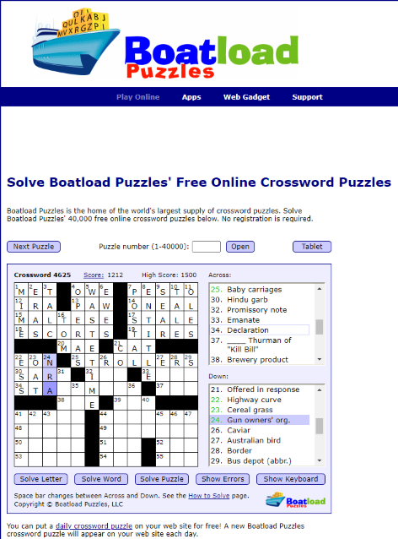

AARP Games
The AARP game site features various games besides crosswords. This is the site I go to daily. I can typically solve a puzzle in about 9 minutes. My best time is 6½ minutes. AARP tracks your time and also scores you. I haven’t determined their scoring algorithm, but it’s based on more than just time to solve.

The puzzles are moderately challenging. The letters are in bold and fairly large, so it’s easy to read. The word and letter highlighting colors are easy to see. You can customize interactions from the menu. Interestingly, the source for AARP’s puzzles is also Boatload puzzles. However, these puzzles are in a 16x16 grid and are more challenging.

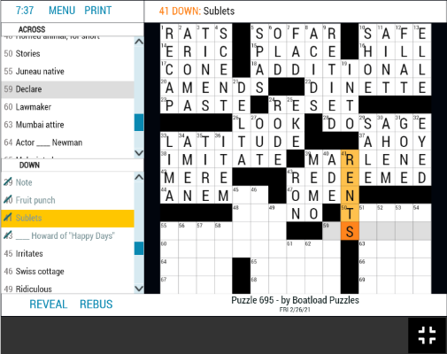

As with many of the puzzle sites, you can also print the current puzzle, either blank, in its current state, or completely solved.

Dictionary.com
Dictionary.com’s puzzles are moderately challenging in a 15x15 grid. Clues may feature “pop culture” references, have double or even triple meanings, or require knowledge of foreign languages. As shown, the letters are displayed large and bold. The highlighting of the current word is in a very pale blue, which can be hard to see. You can click the arrows in the puzzle’s title bar to skip forward and back between puzzles. The clock starts when you first click on a square. You can pause the clock if you have to set the puzzle aside. The puzzles icon next to the gear displays a list of recent puzzles and their status. This lets you work on puzzles you missed or didn’t finish. The gear icon lets you toggle various settings on or off. The most key is whether incorrect letters are flagged in red.

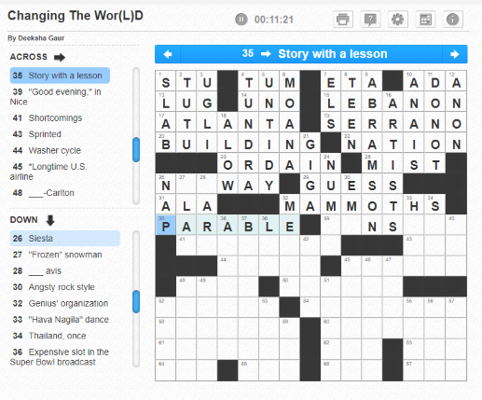
When working on challenging puzzles, I usually have another browser tab open on Google, so I can search for answers to obscure pop culture references like who played some part in an old TV series or the former name of the city of Tokyo. Dictionary.com has its own nice Crossword Solver help feature which offers a list of answers.

Many crossword puzzles are true works of verbal art! Hopefully, I’ve given my readers some insight into online crosswording and offered another way to stay occupied.

